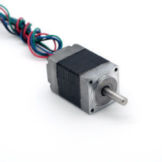

20mm Hybrid Stepper Series

**SPECIFICATIONS:**

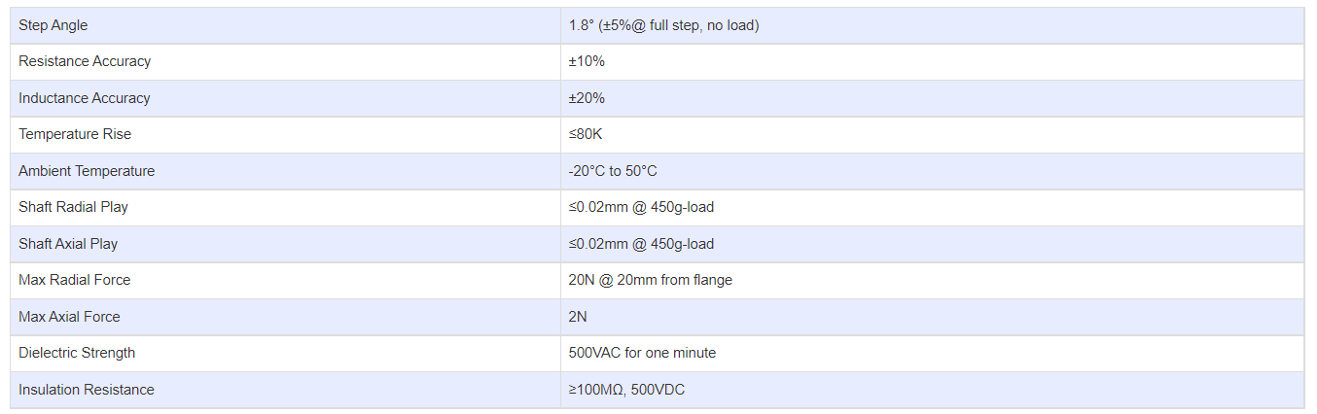

**SUBMODELS:**

*The following are common sub models for the LDO-20STH series.*

